dr.shariat panah | XCS project

bijan mehr alizade-150496288

peyman sharafian-150496162

Xcs report

2018

|  |  |
| --- | --- |
| **parameter** | **value** |
| Population size | 500 |
| Train set size | 1529 |
| Test set | 170 |
| GA threshold “TGA” | 23 |
| Crossover rate | 0.7 |
| Mutation Probability | 0.03 |
| Asmin | 2 |
| Learning coefficient “beta” | 0.6 to 0.1 (**) |
| Accuracy power “gamma” | 5 |
| Minimum prediction error | 2.5 |
| initial prediction | a random number of [0-20] |
| Initial fitness | a random number of [0-20] |
| Initial error (Prediction error of classifier i) | 4* Minimum prediction error |
| Reward | a random number of [0-20] |
| stopping criterion | 90% coverage of test set |

**Maximum & average of fitness**

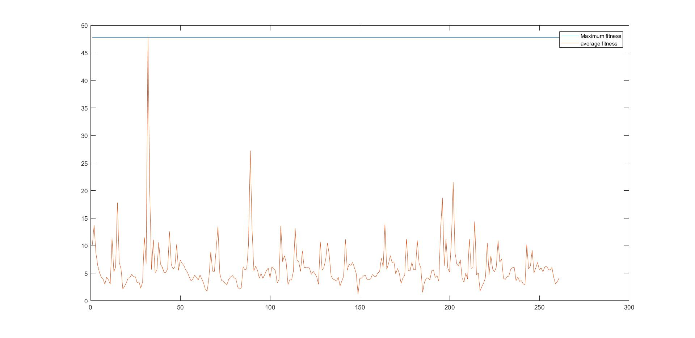

**Stop criterion**

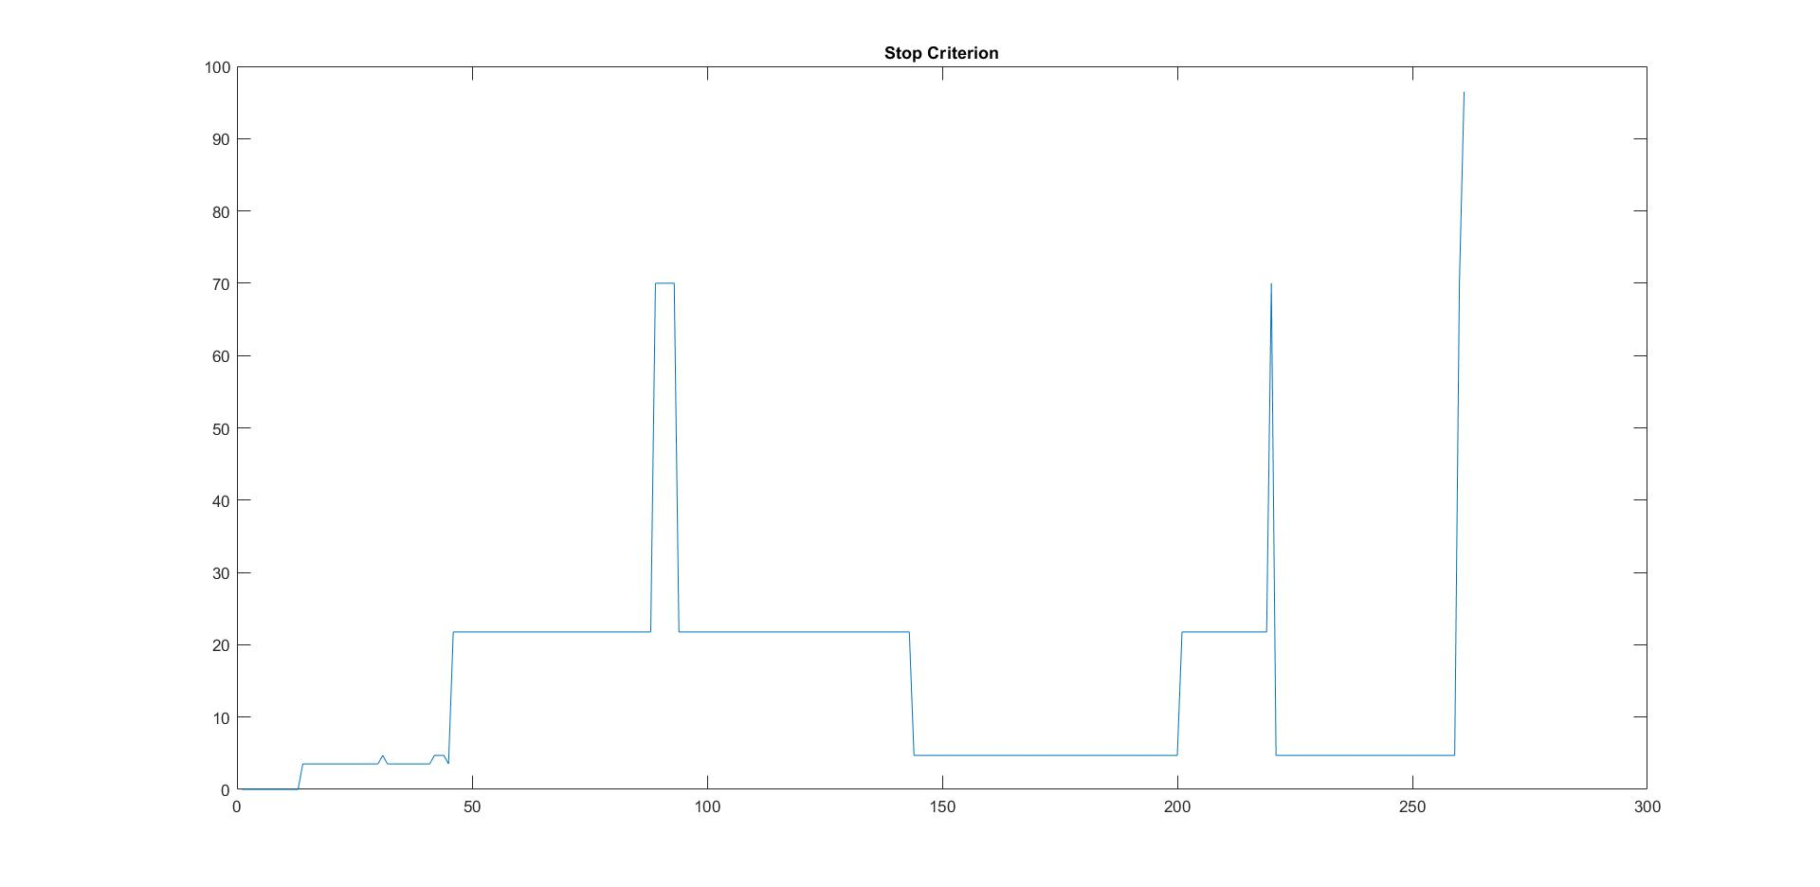

**Generated Classifiers**

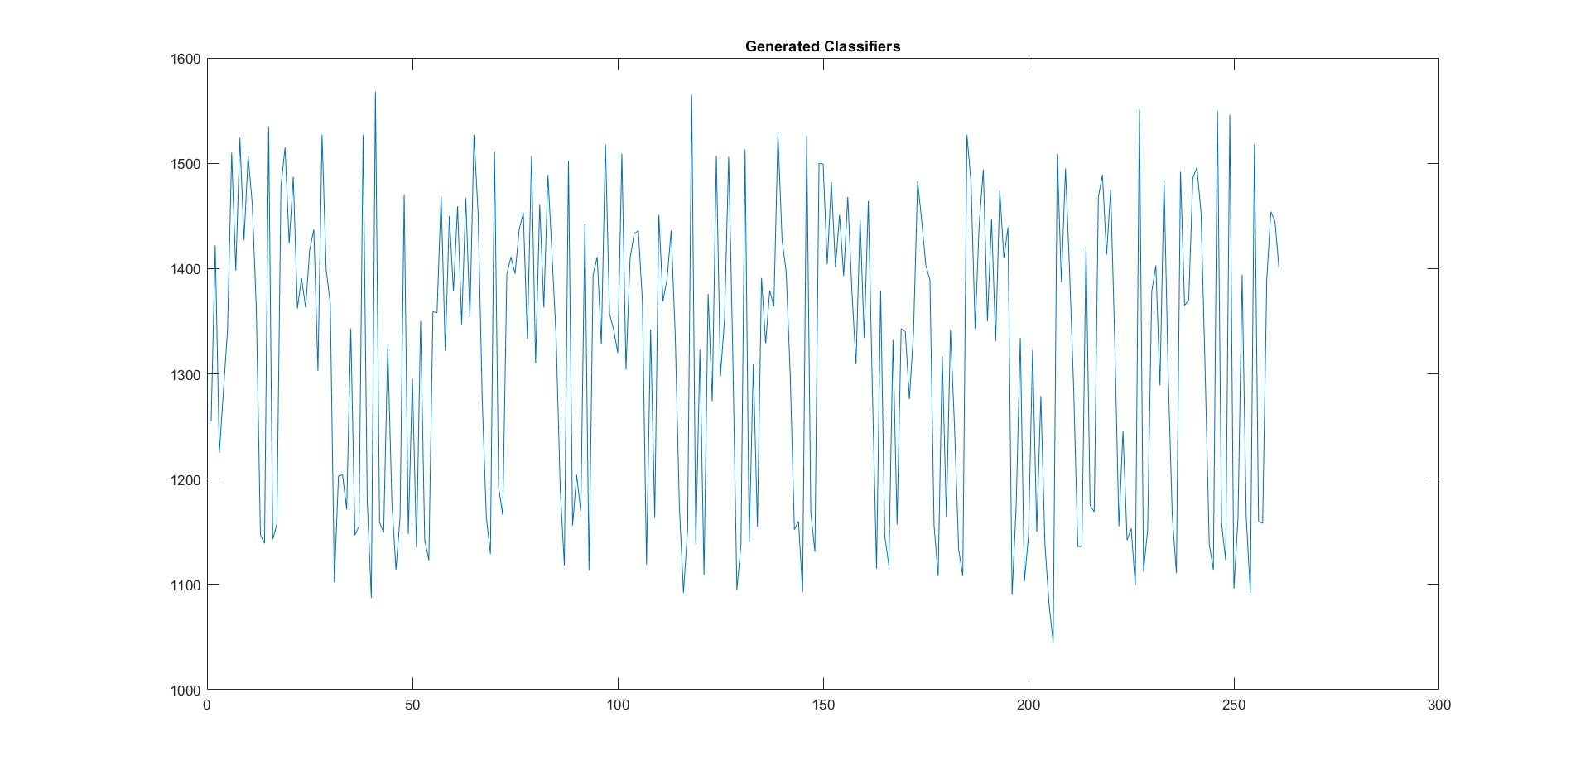

(**): because in primary of epochs our training has low speed and for Improve we use different learning coefficient for the intervals of our epochs between 1 to 800 and above

0 < Beta = 0.6 <250

250 < Beta = 0.6 < 400

400 < Beta = 0.4 <600

600 < Beta = 0.2 < 800

Beta = 0.1 for > 800